# **The Five Digital Senses**

## Your Data Foraging Toolkit

### **The Cue Card System**

Each tool in our toolkit is represented by a two-page cue card containing:

**Page 1: Tool Overview**

* Tool name and basic information
* What it does (core function)
* When to use it (specific scenarios)
* Practical example related to Headspace

**Page 2: Tool Application**

* How to use it (step-by-step instructions)
* What to pair it with (complementary tools)
* Prompt starters (questions/prompts for deeper insights)
* Pro tips (advanced techniques)

These cue cards serve as field guides—quick references during your research journey. Over time, you'll build your personal toolkit by collecting the cards that resonate with your specific needs and style.

Each tool extends one or more of your digital senses, enhancing your natural capacity to perceive patterns, feelings, and meanings.

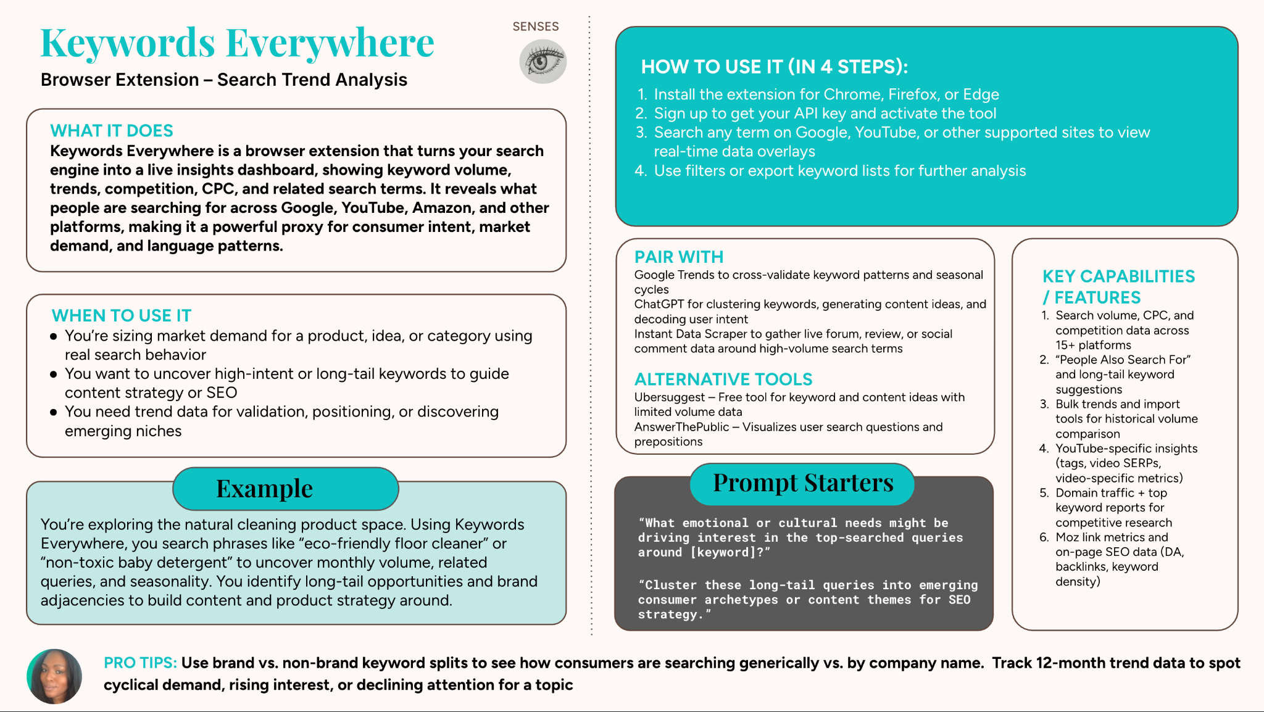

## 

## **Digital Sight: Seeing Patterns and Visual Culture**

### **Core Function**

Digital Sight helps you capture visual patterns, aesthetics, and symbolic meaning. It enables you to:

* Understand how brands position themselves visually
* Identify cultural codes and symbols that resonate with specific audiences
* Track how visual trends evolve over time
* Decode unspoken messages communicated through design choices

### **When to Use Digital Sight**

* Mapping a new territory or market landscape
* Tracking visual evolution over time
* Identifying cultural codes for specific audiences
* Spotting emerging visual trends
* Comparing competitor visual positioning

### **Spotlight Tools**

**GoFullPage**

* Chrome extension that captures entire webpages as screenshots
* Preserves the complete scroll experience
* Essential for understanding narrative and design connections
* Creates visual documentation of user experience

**Pinterest Collections**

* Platform for gathering, organizing, and analyzing visual patterns
* Create boards for different brands, emotional territories, or design approaches
* Provides canvas for visual pattern recognition
* Helps identify aesthetic trends and visual language

**Visual Comparison Techniques**

* Methods for placing visual artifacts side by side
* Identify patterns, differences, and emotional qualities
* Simple as screenshots in a document or sophisticated as mapping software
* Reveals positioning and emotional differences across competitors

### **Application Example**

With Headspace, capturing screenshots of their interface alongside competitors like Calm and Ten Percent Happier could reveal:

* Headspace uses rounded shapes and gentle transitions to create accessibility
* Calm uses spacious, nature-inspired imagery to evoke transcendence
* Ten Percent Happier uses more straightforward, practical visuals

This visual insight might transform how you position your own product or service.

## **Digital Hearing: Tuning into Authentic Conversations**

### **Core Function**

Digital Hearing helps you capture authentic conversations and their emotional context. It enables you to:

* Understand how people naturally describe experiences and challenges
* Identify terminology and metaphors that resonate in specific communities
* Map the emotional landscape around your product category
* Discover questions, concerns, and aspirations shaping the conversation

### **When to Use Digital Hearing**

* Understanding emotional resonance of products or experiences
* Detecting terminology and expressions used naturally
* Identifying pain points not explicitly mentioned
* Exploring broader cultural conversations
* Discovering unexpected use cases

### **Spotlight Tools**

**Google Boolean Search**

* Sophisticated search techniques to find specific conversation types
* Operators include site:, OR, AND, and quotation marks
* Helps uncover precisely the conversations you're seeking
* Enables targeted searches across platforms

**Instant Data Scraper**

* Chrome extension for collecting comments, reviews, and posts
* Transforms hours of manual work into quick, automated process
* Gathers authentic conversations at scale
* Provides structured datasets for analysis

**Reddit and Forum Search Techniques**

* Methods for finding communities with genuine discussions
* Strategies for navigating nested comments and threads
* Helps identify the most revealing conversations
* Uncovers insights that formal research would miss

### **Application Example**

With Headspace, you might use Boolean search to find meditation discussions on Reddit, then use Instant Data Scraper to collect these conversations.

You could discover that while Headspace's marketing focuses on "mindfulness" and "calm," users frequently discuss meditation in terms of "showing up," "staying consistent," and "forgiving myself when I miss a day"—revealing a tension between aspiration and reality that could inform product features or messaging.

## **Digital Touch: Feeling User Experiences**

### **Core Function**

Digital Touch helps you sense how people navigate and interact with digital spaces. It enables you to:

* Map the complete paths people take through digital experiences
* Identify where users encounter friction, confusion, or delight
* Understand how people actually use products (versus design intentions)
* Feel the emotional journey accompanying interactions

### **When to Use Digital Touch**

* Mapping user journeys and key touchpoints
* Discovering friction points and abandonment moments
* Understanding behavioral patterns and interaction preferences
* Accessing "dark data" (hidden user interactions)
* Experiencing firsthand what users feel

### **Spotlight Tools**

**Browserflow**

* Automation tool that simulates user journeys and extracts data
* Creates recordings of specific paths through websites
* Identifies exactly where and how users interact with elements
* Enables systematic exploration of complex journeys

**Session Recording and Heatmap Tools**

* Solutions like Hotjar (with generous free tier)
* Capture real user interactions including mouse movements, clicks, and scrolling
* Provide direct window into actual user experiences
* Reveal behavioral patterns invisible in traditional analytics

**Journey Mapping Techniques**

* Methods for visualizing complete user experiences
* Include emotional states across key touchpoints
* Move beyond documenting steps to feeling experiences holistically
* Connect functional actions with emotional responses

### **Application Example**

With Headspace, you might use session recordings to observe how new users navigate their first meditation experience, noticing hesitations when selecting a practice length or confusion about features.

You might discover that while users say they want variety, their behavior shows they return to the same few meditations repeatedly—an insight that could reframe your content strategy.

## **Digital Smell: Detecting Subtle Signals**

### **Core Function**

Digital Smell helps you detect subtle signals and unmet needs. It enables you to:

* Identify what people desire but aren't explicitly requesting
* Spot early indicators of changing preferences or problems
* Understand deeper drivers behind stated preferences
* Sense quality perception beyond functional metrics
* Discover opportunity spaces competitors haven't addressed

### **When to Use Digital Smell**

* Identifying unmet needs and latent desires
* Detecting emerging trends before mainstream awareness
* Uncovering subconscious motivations
* Sensing quality perception beyond features
* Finding opportunity spaces in the market

### **Spotlight Tools**

**VideoAsk**

* Tool for capturing video responses from users
* Preserves facial expressions, tone of voice, and authentic reactions
* Provides access to unguarded moments where true feelings emerge
* Creates more natural, conversational feedback

**Versive**

* AI-moderated interview tool that conducts conversations
* Asks follow-up questions based on user responses
* Creates natural dialogue flow
* Reveals insights traditional surveys would miss

**Techniques for Detecting What's "Off"**

* Methods for identifying discrepancies between words and meaning
* Looking for hesitations, qualifications, or off-topic comments
* Noticing emotional incongruence in responses
* Identifying signals that conventional research would miss

### **Application Example**

With Headspace, you might use VideoAsk to capture users' immediate reactions after completing a meditation session, noticing subtle facial expressions indicating confusion or relief.

You might discover many users experience tension between wanting meditation to be guided enough to prevent mind-wandering but open enough to feel like personal discovery—a nuanced insight that could inspire new features.

## **Digital Taste: Refining Through Experimentation**

### **Core Function**

Digital Taste helps you test, refine, and personalize experiences. It enables you to:

* Identify which concepts resonate most strongly with your audience
* Optimize existing experiences for better engagement
* Understand what content and features appeal to different segments
* Determine which messaging creates the strongest response
* Create adaptive experiences that respond to user preferences

### **When to Use Digital Taste**

* Validating concepts before full investment
* Refining existing experiences
* Creating personalized content for different segments
* Testing value propositions and messaging
* Establishing ongoing optimization processes

### **Spotlight Tools**

**A/B Testing Approaches**

* Methods for comparing different versions of content or features
* Doesn't require enterprise software; simple tools work effectively
* Provides clear feedback on what resonates
* Supports data-driven decision making

**Personalization Techniques**

* Approaches for tailoring experiences based on preferences or behaviors
* Includes content recommendations, interface adjustments, messaging variations
* Creates more relevant user experiences
* Allows for segment-specific optimization

### **Application Example**

With Headspace, you might use IMPORTXML to gather data about which meditation topics get the most engagement, then use simple A/B tests to try different introduction approaches.

You might discover that while everyone says they want long meditations, beginners actually complete short sessions at much higher rates—leading you to create a progressive approach that gradually increases duration as users build their practice.

## **The Art of Multi-Sensory Research**

Different senses work together like instruments in an orchestra—each with its unique contribution, but creating magic when played in harmony.

### **Example Combinations**

**For understanding abandonment issues:**

* Digital Touch → map abandonment points
* Digital Hearing → understand user frustrations
* Digital Smell → detect unmet needs driving abandonment

**For exploring new product positioning:**

* Digital Sight → analyze competitor positioning
* Digital Hearing → understand user language
* Digital Taste → test messaging approaches

**For improving existing experiences:**

* Digital Touch → identify friction points
* Digital Taste → test potential improvements
* Digital Hearing → validate that improvements address concerns

### **Personal Reflection**

* Which digital senses feel most natural to you?
* Which senses feel less developed?
* What tools or techniques sparked your curiosity?

This curiosity—the desire to sense more deeply—is the heart of the forager's mindset we're cultivating together.

In our next lesson, we'll explore how to design comprehensive listening stacks—combinations of tools, senses, and ways of knowing that address specific business questions. We'll examine recipes for clarity, opportunity, experience repair, innovation, and cultural sensing.